

MYSURVEILLANCE

Admin Manual

Research & Development Unit
Open Source Competency Centre (OSCC),
MAMPU,
Lot E302-34, Enterprise Building 3,
63000 Cyberjaya, Selangor
Tel: 03-8319 1200
Fax: 03-83193206
http://opensource.mampu.gov.my

TABLE OF CONTENTS

Introduction |  | 1
Features |  | 1
Hardware and Software |  | 2
Architecture |  | 3
Dependencies |  | 5
Prerequisites |  | 7
Installation Steps |  | 9
 | Installing MySurveillance Server | 9
 | Adding client to the system | 11
Administration |  | 14
 | Main Page | 14
 | Agents Page | 16
 | Change Password | 17
 | Add User | 18
Maintenance |  | 19

Introduction

MySurveillance is a security monitoring system application that collects and analyzes security reports from all network devices and system applications such as firewalls, databases, web servers and switches. MySurveillance client-server architecture helps organizations/individuals to monitor all security alerts for devices or applications from a central (MySurveillance server).
Each client that need to be monitored will be installed with a MySurveillance sensor which will collect the security event logs and Intrusion Detection Message Exchange Format (IDMEF) will translate the log to a common language using IDMEF before sending it to the MySurveillance server for analysis. Report of all security events will be displayed at the MySurveillance Console.

Features

Some of the features available in MySurveillance are:
- Able to support log files generated by various devices and applications available in the market.
- Real-time analysis of events received from MySurveillance Sensor
- Built-in event log filter enables only critical and error messages to be displayed at central server.
- Data can be collected and corellated from sensors deployed on supported devices.

Hardware and Software

 | Manager | Client
Hardware | Pentium IV and above  512MB RAM and above  10GB HD and above | No specification
Software | MySQL  Apache  libprelude  libpreludedb  prewikka
Software | CentOS5  prelude-manager | Open Source Independent  mysurveillance-client  prelude-lml

Architecture

There are four components involved in MySurveillance which are MySurveillance Sensors/Agents, MySurveillance Server, MySuveillance Data Store and MySurveillance Console.
- Sensors/Agents at the client-server (prelude-lml) are responsible for intrusion detection, and report events in a centralized fashion using a Transport Layer Security (TLS)
- All the report of security events will be collect and analyze at MySurveillance Server (prelude-manager).
- MySurveillance uses Intrusion Detection Message Exchange Format (IDMEF) as the common language for reporting events. The server can then process these events and deliver them to a MySurveillance Data Store.
- The MySurveillance Console can then be used to view these events log reading the information from the MySurveillance Data Store.

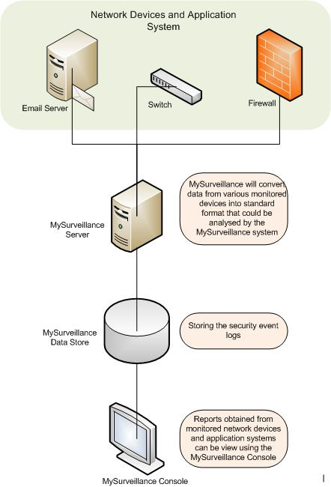
Figure 4.1 : Architecture Diagram

Dependencies

MySurveillance-server
==================================================================== Package Arch Version Repository Size
====================================================================
Installing:
mysurveillance-server i386 1.1-1.oscc oscc-repo 2.2 k
Installing for dependencies:
libprelude i386 0.9.17.2-1 oscc-repo 985 k
libprelude-python i386 0.9.17.2-1 oscc-repo 520 k
libpreludedb i386 0.9.14.1-1 oscc-repo 196 k
libpreludedb-mysql i386 0.9.14.1-1 oscc-repo 28 k
libpreludedb-python i386 0.9.14.1-1 oscc-repo 90 k
mysurveillance-client i386 1.0-2.oscc oscc-repo 1.9 k
oscc-bayesian noarch 0.0.2-4.oscc oscc-repo 2.2 M
oscc-tracking noarch 0.0.2-1.oscc oscc-repo 29 k
perl-Archive-Tar noarch 1.30-1.fc6 base 47 k
perl-Compress-Zlib i386 1.42-1.fc6 base 52 k
perl-Digest-HMAC noarch 1.01-15 base 12 k
perl-Digest-SHA1 i386 2.11-1.2.1 base 48 k
perl-HTML-Parser i386 3.56-1 oscc-repo 124 k
perl-IO-Socket-INET6 noarch 2.51-2.fc6 base 13 k
perl-IO-Socket-SSL noarch 1.07-2.el5.rf oscc-repo 43 k
perl-IO-Zlib noarch 1.04-4.2.1 base 15 k
perl-Net-DNS i386 0.61-1.el5.rf oscc-repo 276 k
perl-Net-Daemon noarch 0.43-1 oscc-repo 44 k
perl-Net-IP noarch 1.25-2.fc6 base 31 k
perl-Net-SSLeay i386 1.30-4.fc6 base 195 k
perl-Socket6 i386 0.19-3.fc6 base 22 k
perl-libwww-perl noarch 5.805-1.1.1 base 376 k
prelude-lml i386 0.9.12.2-5 oscc-repo 187 k
prelude-manager i386 0.9.12.1-1 oscc-repo 192 k
prewikka noarch 0.9.14-1 oscc-repo 420 k
python-cheetah i386 2.0-0.1.rc8.el5.rf oscc-repo 423 k
spamassassin i386 3.2.4-1.el5 base 1.0 M

MySurveillance-client
====================================================================Package Arch Version Repository Size
====================================================================
Installing:
mysurveillance-client i386 1.0-2.oscc oscc-repo 1.9 k
Installing for dependencies:
libprelude i386 0.9.17.2-1 oscc-repo 985 k
oscc-tracking noarch 0.0.2-1.oscc oscc-repo 29 k
prelude-lml i386 0.9.12.2-5 oscc-repo 187 k

Prerequisites

Prelude-manager
Prelude Manager is the main program of MySurveillance system. It is a multithreaded server which handles connections from the MySurveillance sensors. It is able to register local or remote sensors, enable the operator to configure them remotely, receive and store alerts in a database or any format supported by reporting plugins, thus providing centralized logging and analysis. It also provides relaying capabilities for failover and replication. Support for filtering plugins allows you to hook in different places in the Manager to define custom criteria for alert relaying and logging.

Prelude-lml
The Prelude Log Monitoring Lackey (LML) is the host-based sensor program component. It can act as a centralized log collector for local or remote systems. It can run as a network server listening on a syslog port or analyze log files. It supports logfiles in the Berkeley Software Distribution (BSD) syslog format and is able to analyze any logfile by using the Perl Compatible Regular Expressions (PCRE) library. It can send an alert to the Prelude Manager when a suspicious log entry is detected.

Libprelude Library
Libprelude is the library that provides the framework used to access the Prelude system. It handles secure communications with the MySurveillance sensor, and provides an Application Programming Interface (API) to create Intrusion Detection Message Exchange Format (IDMEF) based events. It also provides important features like fail-over (by saving to a local file for later retransmission later and usage of a fallback route), in case one of the MySurveillance servers goes down. Moreover, it gives you the ability to create sensors that read events received by one or more MySurveillance servers.

Libpreludedb Library
The PreludeDB Library provides an abstraction layer based upon the type and the format of the database used to store Intrusion Detection Message Exchange Format (IDMEF) alerts. It allows developers to use the MySurveillance Data Store easily and efficiently without worrying about Structured Query Language (SQL), and to access the MySurveillance Data Store independently of the type/format of the database.

Prewikka
Prewikka is a web-based management console for MySurveillance. Some of the features available in Prewikka are contextual filtering, aggregation and permission management.

Apache HTTP Server (for MySurveillance Console)
The Apache HTTP Server is the most popular Open Source and widely used web server in the world. The Apache HTTP server is known to be a stable and extensible server.

Centos Linux Operating System
CentOS is an Enterprise-class Linux Distribution derived from sources freely provided to the public by Red Hat . CentOS conforms fully with the upstream vendors redistribution policy and aims to be 100% binary compatible to Red Hat Enterprise Linux.

MySQL (for MySurveillance Data Store)
MySQL is a very popular and widely used Open Source database that is known for its robustness and ease of use. Some features available are multiple storage, query caching, Secure Sockets Layer (SSL) support and many more.

Installation Steps

There are two steps of installation involved with installation of the admin-server with an IP of 192.168.0.1 and a client-server with an IP of 192.168.0.2 to the system.

Section 1: Installing the mysurveillance server

1) To sync date and time at the server to an NTP server, run the command:

ntpdate pool.ntp.org
service ntpd start
chkconfig ntpd on

2) Install/Enable the OSCC repos:

rpm -Uvh http://repos.oscc.org.my/repos2/centos/5/oscc/i386/CentOS/oscc-repos2-0.0.1-1.noarch.rpm

3) Install mysurveillance-server

yum install mysurveillance-server

4) Change configurations in the /etc/prelude-manager/prelude-manager.conf file

listen = SERVER_IP
(eg: 192.168.0.1)

5) Add prelude-manager to the system by run this command

prelude-admin add "prelude-manager" --uid 0 --gid 0

6) Start prelude-manager service by run this command

service prelude-manager start

7) After the installation is complete, open web browser.

http://SERVER_IP/mysurveillance
(eg: http://localhost/mysurveillance)
or (eg: http://192.168.0.1/mysurveillance)

**Use this default login and password, but we recommend that you change the password as soon as possible for security purposes .

login: admin
password: admin

Section 2: Adding client to the system

Installation steps for the client:

1) To sync date and time at the client-server to ntp time, run command:

ntpdate pool.ntp.org
service ntpd start
chkconfig ntpd on

2) Install/Enable OSCC repos

rpm -Uvh http://repos.oscc.org.my/repos2/centos/5/oscc/i386/CentOS/oscc-repos2-0.0.1-1.noarch.rpm

3) Install mysurveillance-client

yum install mysurveillance-client

4) Change the following in the config files:

4.1) /etc/prelude/default/client.conf

server-addr = IP_ADMIN_SERVER
(eg: 192.168.0.1)

4.2) /etc/prelude/default/global.conf

analyzer-name = NAME
(eg: test)
node-name = MACHINE_NAME
(eg: oscc1)
node-location = COMPANY_NAME
(eg: OSCC)
node-category = REFER_NODE_TYPE
(eg: unknown)

[Node-Address]
address = IP_ADDRESS
(eg: 192.168.0.2)

4.3) /etc/prelude-lml/prelude-lml.conf

comment out all command in the config file EXCEPT:
[format=syslog]
time-format = "%b %d %H:%M:%S"
prefix-regex = "^(?P<timestamp>.{15}) (?P<hostname>\S+) (?:(?P<process>\S+?)(?:\[(?P<pid>[0-9]+) \])?: )?"
file = /var/log/messages
file = /var/log/secure
file = /var/log/httpd/access_log

5) Add client to the system by run this command

prelude-admin register prelude-lml "idmef:w admin:r" IP_ADMIN-SERVER --uid 0 --gid 0
(eg: prelude-admin register prelude-lml "idmef:w admin:r" 192.168.0.1 --uid 0 --gid 0)

**It will ask you to enter one-shot password provided from admin-server (please refer to the admin server configuration #6 before you proceed to the next step).

7) Start prelude-lml service by run this command

service prelude-lml start

Installation step at the server

6) Register client to the server by run this command

prelude-admin registration-server prelude-manager

**Use the password given for configuration #5 at the client-server.

Administration

Main Page
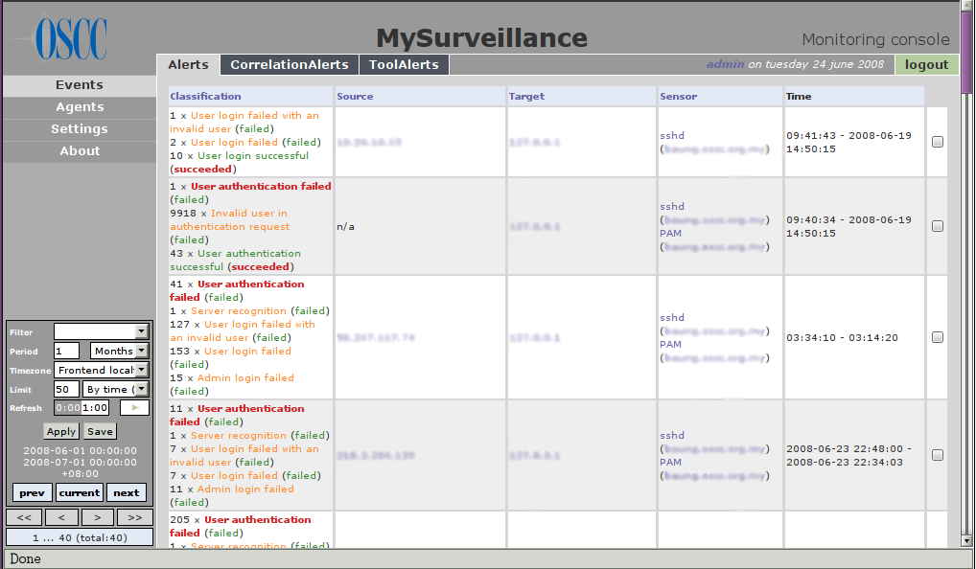
All of security events from network devices and application systems that MySurveillance monitors will be displayed at the MySurveillance Console, as shown in Figure 1.
Figure 1 : MySurveillance Main Page
Selection Menu
Display
Setting Panel
There are 4 menu selections can be chosen when you login into MySurveillance Console which are Events, Agents, Settings and About. Some features that are available in the Display Setting panel are adjustable period for displaying reports, limitation to how many reports to be displayed in each page and refresh interval.
There are 3 pages to be display under Events which are Alert, CorrelationAlert and ToolsAlert. A double-click at the respective security event at the Classification column will open a different screen with detail information for the security event as shown in Figure 2.
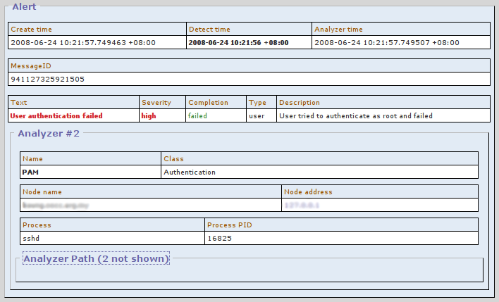
Figure 2 : Security Event Details

Agents page
Network devices or application systems that have been registered under MySurveillance system will be displayed at the Agent page. Sensors or agents will be grouped depending on the devices location. There are 2 colour codes used to refer to the availability of the sensors or agents at a particular time. Green refers to the availability of the sensors and red refers to the missing sensors.

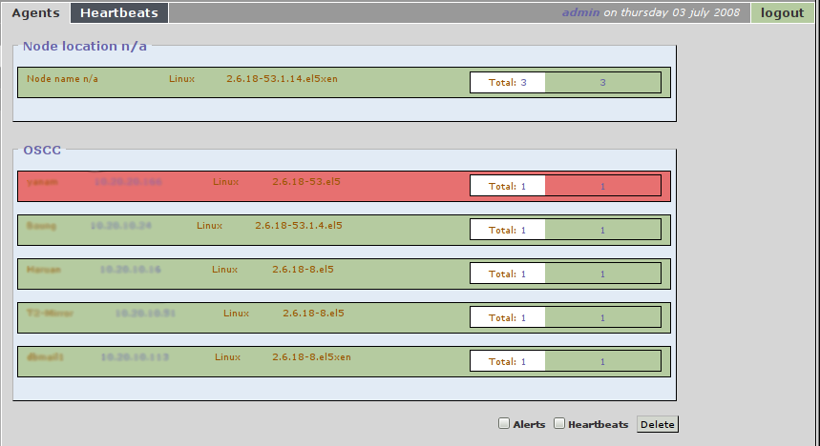
Figure 3 : Agents page

Change password
- To change password, first click Settings on the left panel.
- Next, click User listing as shown below. It will show a list of user accounts with its permissions.
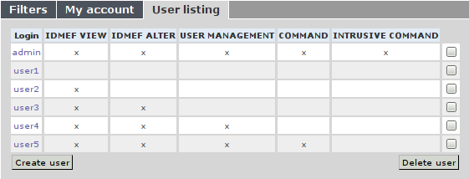
- Click on the required username in the Login column.
- It will open up Account information for the user you had choose.
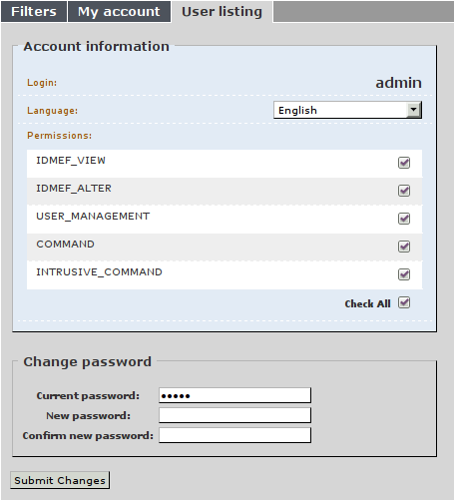
- In the Change password section, fill in your Current password, New password and Confirm new password.
- Click on Submit Changes to update you new password.

Add User
- To add user, first click Settings on the left panel.
- Next, click User listing as shown below. Click on button Create user.
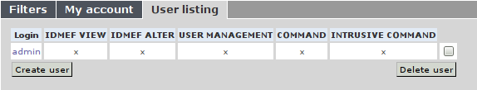
- Fill up the details for new user in the space provided. Specified permissions for the user at the Permissions box.
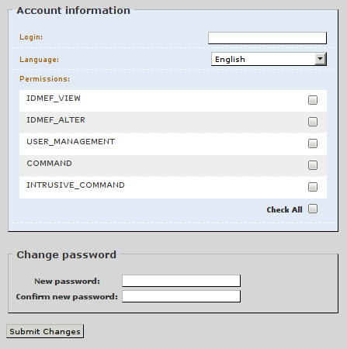

- Click Submit Changes to update new user.

Maintenance
The following should be checked on a regular basis:

Network connections
The administrator should verify the server is reachable from the public network to avoid service interruption. Network monitoring is beyond the scope of these manual.

Log files
With the log files, it is possible to identify and monitor hardware and software problems on the servers. The log files should be checked at least once a week. All log files in /var/log/ directory.

Services
Used to start, stop or cancel a service on a local or remote computer. It is also a tool to set up recovery actions to take place if a service should fail. Should be checked in case of service failure.

#/etc/init.d/[service_name] start/stop/status
e.g:
#/etc/init.d/prelude-manager start
#/etc/init.d/ prelude-manager stop
#/etc/init.d/ prelude-manager status

Package update/patch
Check that the latest package update/patches has been installed on the servers. It should be checked and done at least once a month.

Disk Space
to verify that there is always enough space on the most mission critical servers. It should be done at least once a week. Use df -h command.

Password change
Password should be changed periodically, at least every three months.

